12/4/2020

CIS4366 Final Project

By: Aditya Koul

Synopsis/Summary

I work as a computer forensic examiner for the Jacksonville Sheriff’s Office. Detective Sherlock Holmes of the Economic Crimes Unit is investigating credit-card fraud involving the suspect Chris Frauder. Detective Holmes served a search warrant at Frauder’s home, 123 Acme Street, on 11-19-2020. Ecstatic about the new case, I imaged it as soon as I acquired it on 1-19-2020. The case number assigned to this case is 20-111919.

Evidence/RelevantFindings

Screenshot of Image Verification Hash

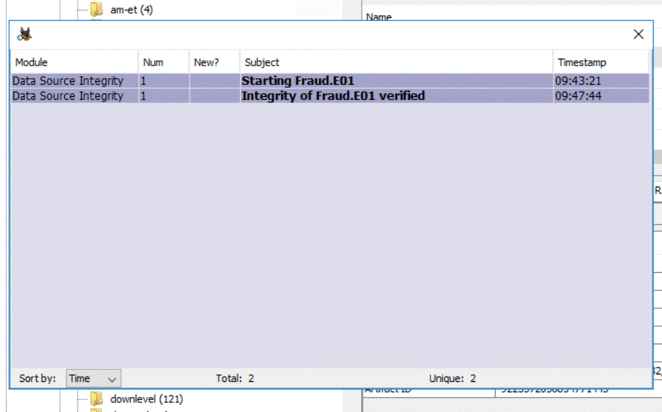

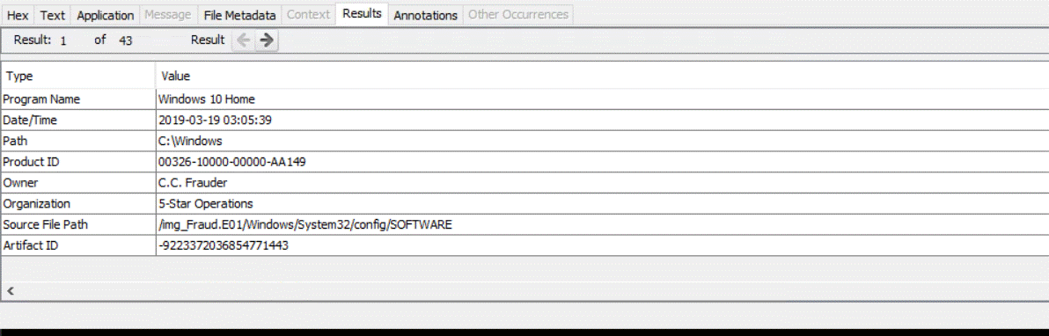Screenshot Caption: displays: Computer Name, Windows Version, Registered Owner, and Registered organization of the laptop the detective seized via the search warrant

Screenshot of the SHA-1 Hash of Fraud.E01 before exam

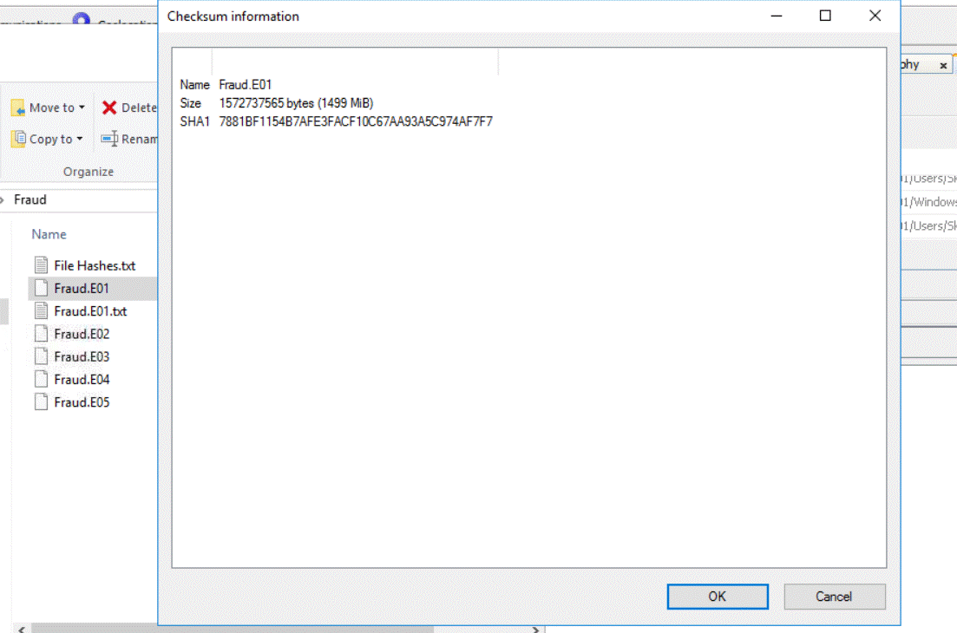Screenshot of the SHA-1 Hash of Fraud.E01 before exam

Screenshot SHA-1 of the Hash of Fraud.E01 after exam



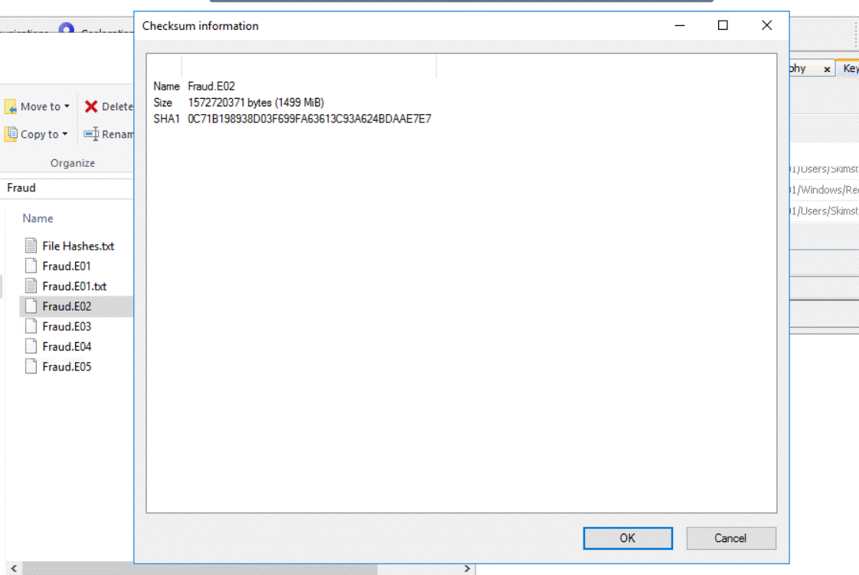Screenshot of the SHA-1 Hash of Fraud.E02 before exam



Screenshot of the SHA-1 Hash of Fraud.E02 after exam

Screenshot of the SHA-1 hash of Fraud.E03 before exam

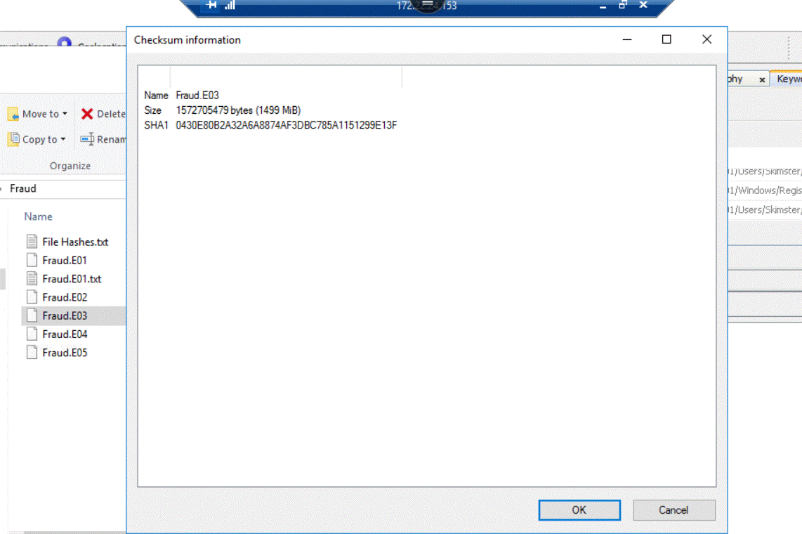

Screenshot of the SHA-1 hash of Fraud.E03 after exam

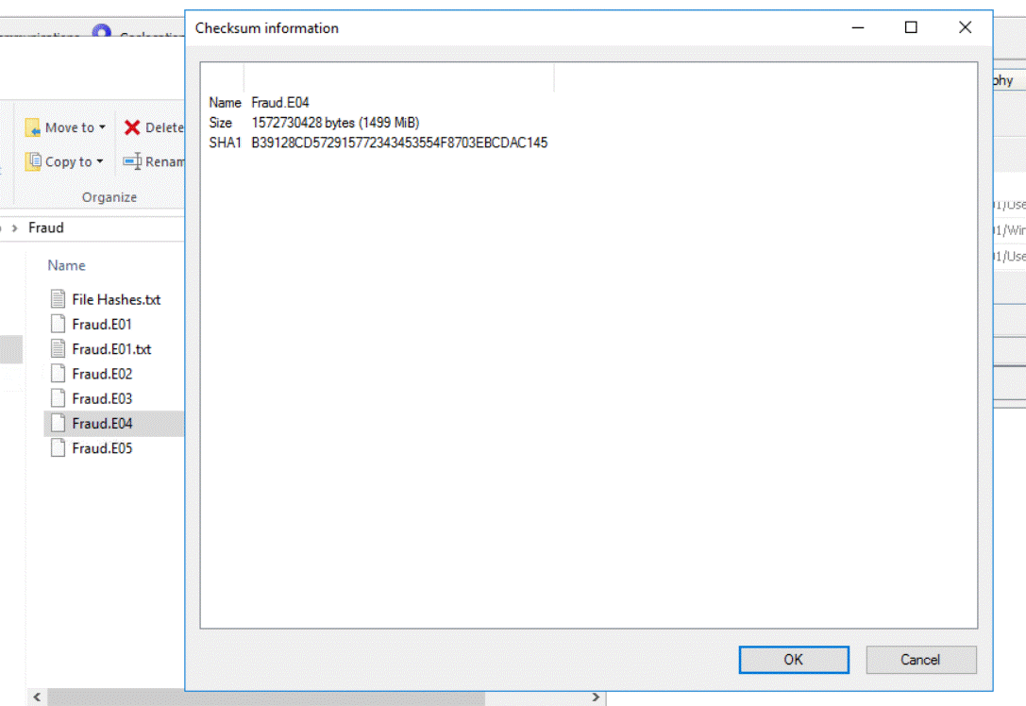Screenshot of the SHA-1 hash of Fraud.E04 before exam

Screenshot of the SHA-1 hash of Fraud.E04 after exam



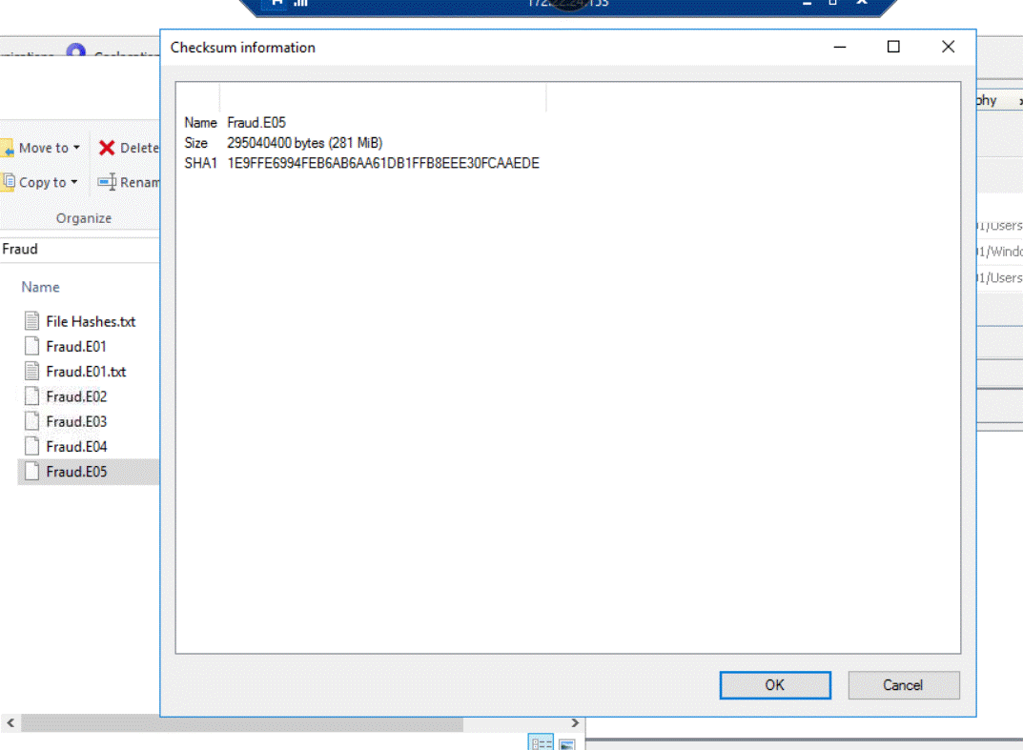 Screenshot of the SHA-1 hash of Fraud.E05 before exam

Screenshot of the SHA-1 hash of Fraud.E05 after exam



Screenshot of Suspect’s Email Address

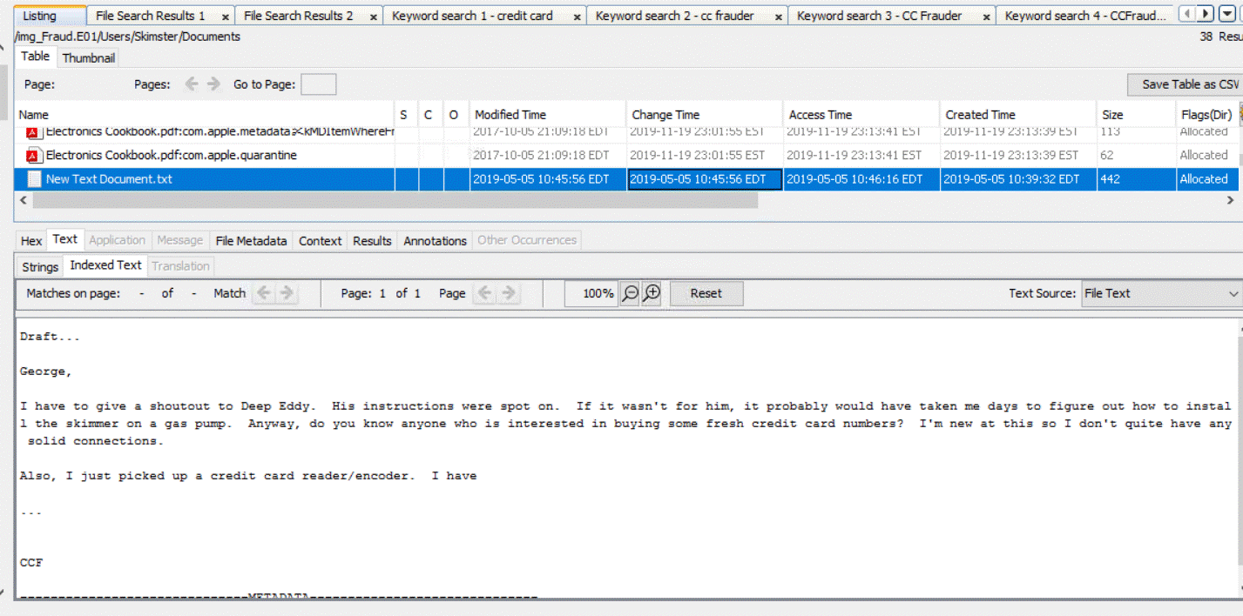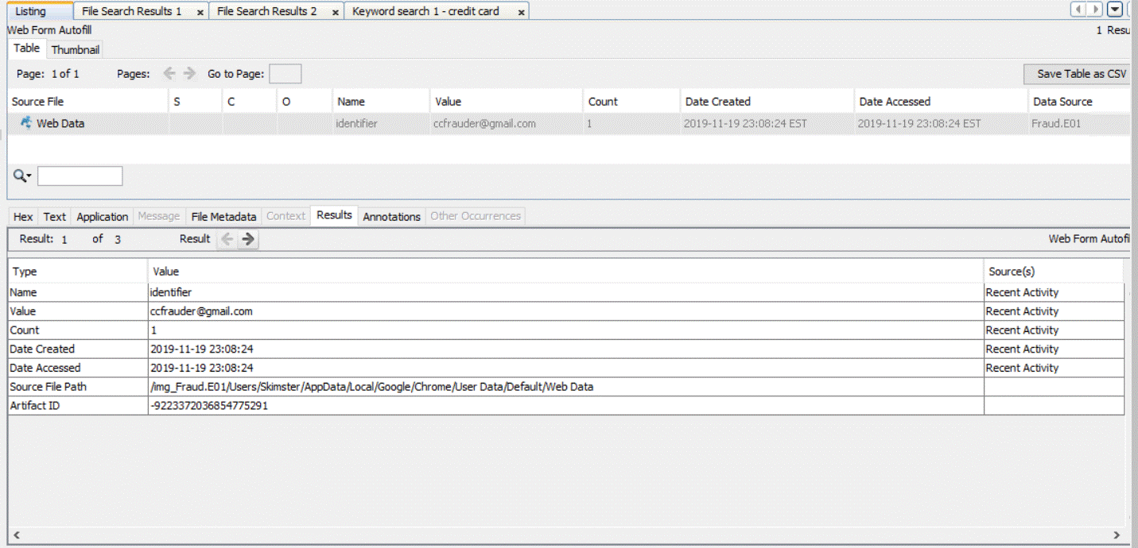Screenshot of Name of person(s) to whom Frauder may have communicated with or intended to communicate with

Were any USB devices attached?  If so, what

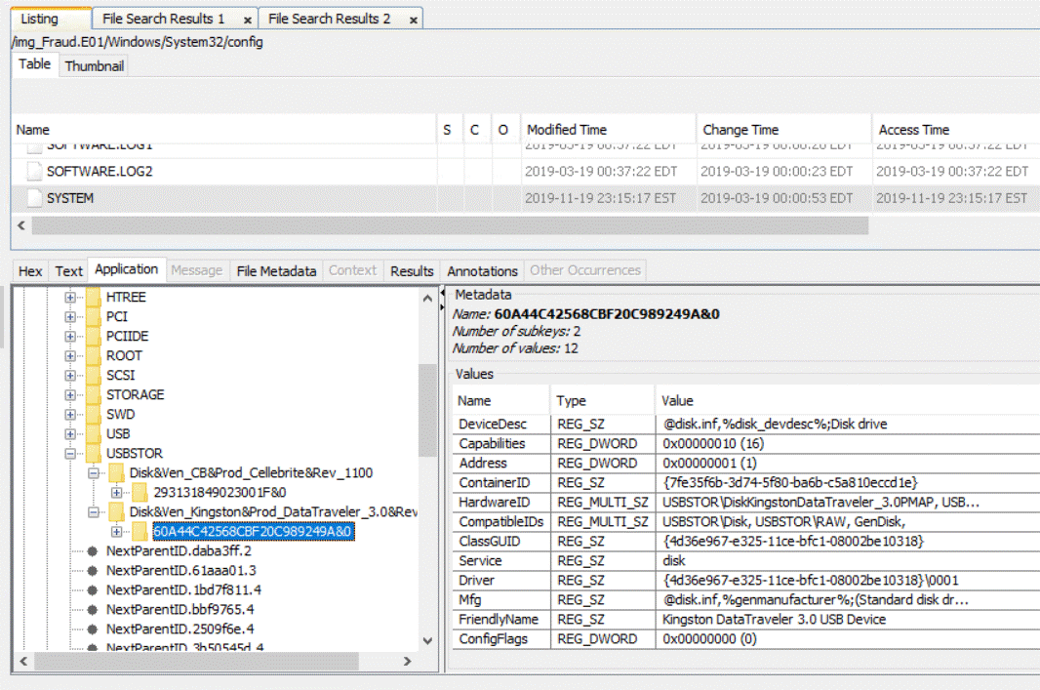

Screenshot depicts Frauder looked up different kinds of ATM skimmers, so he’d be able to steal customers credit-card infromation when they used the ATM machine

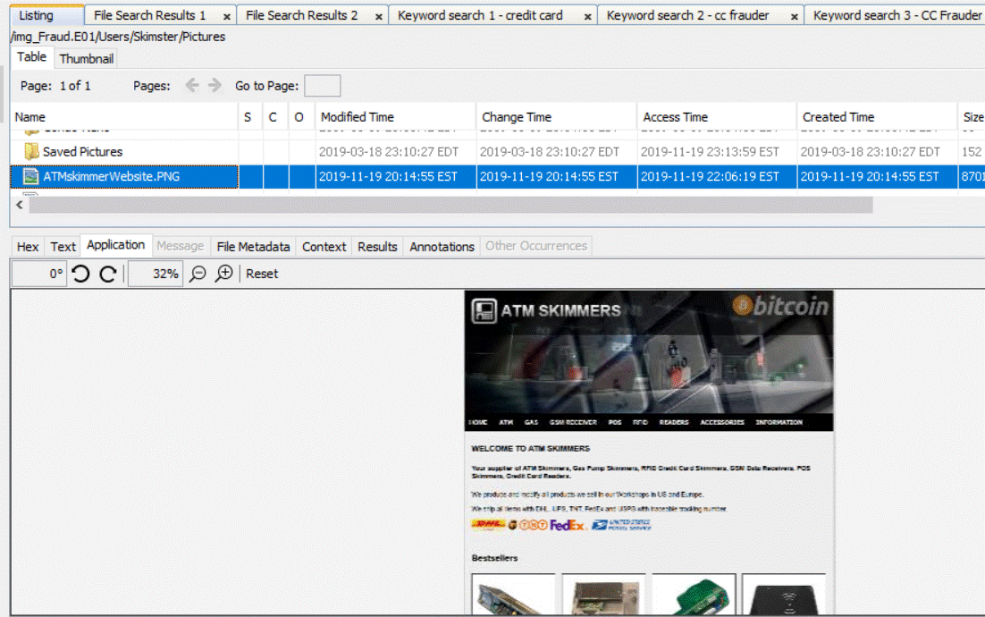

Screenshot shows that Frauder looked up something called Canon which I’m guessing is probably related to Canon cameras which he most likely used to take pictures of the stolen credit-cards

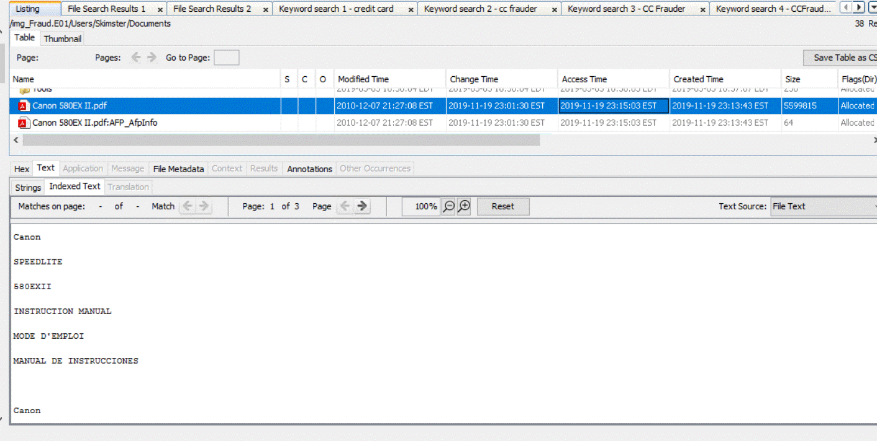

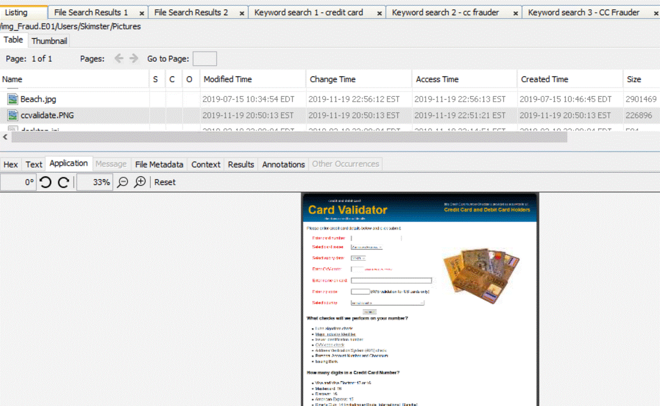 Screenshot displays that Frauder looked up how to validate the information he stole from his victims’ credit-cards, so he’d be able to use the funds on them to purchase things

Screenshot shows that Frauder researched how to befriend his victims before he stole their credit-card information 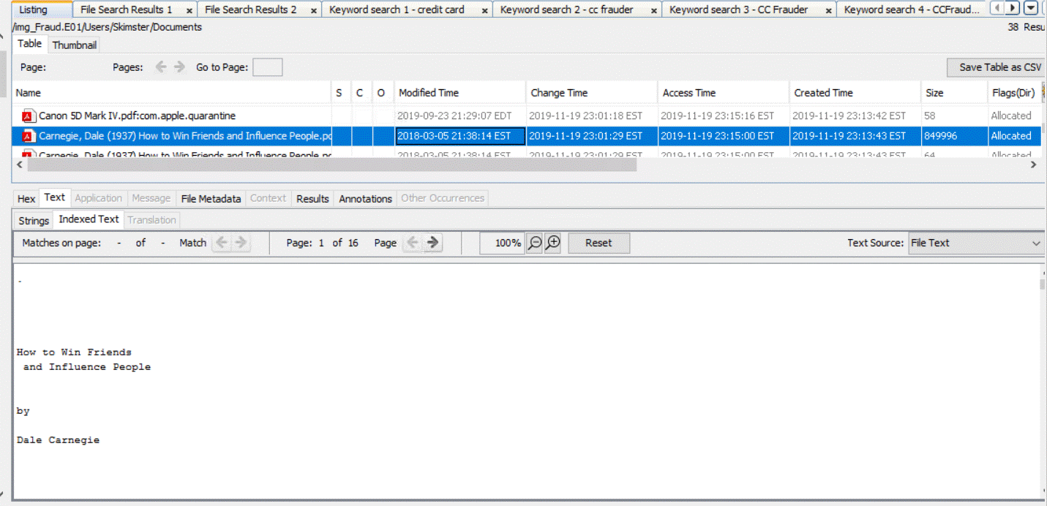

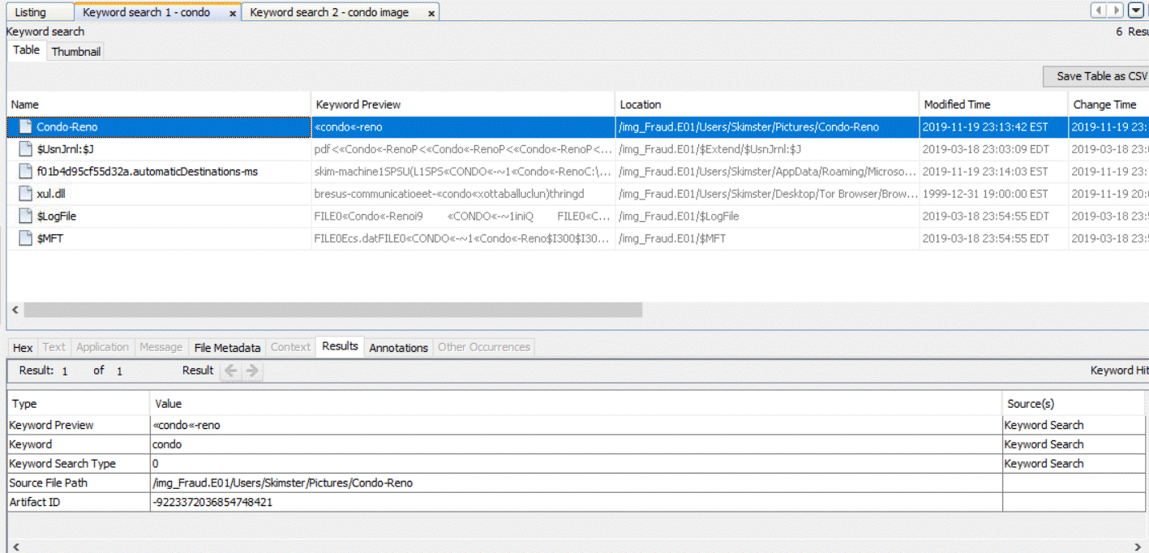Screenshot shows evidence that Frauder looked up condos so he could purchase one to either renovate it with the money he stole or to use as a stash pad for the stolen money

Screenshot displays evidence Frauder made a list of the credit-card information he stole from his victims

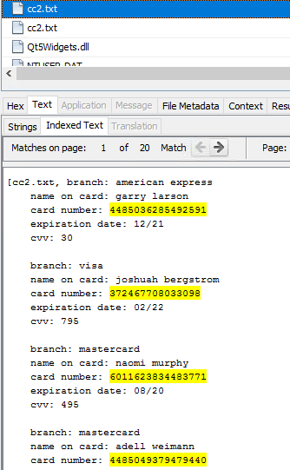

Screenshot shows proof that Frauder researched credit-card scanning softwares so he could steal people’s credit-card information

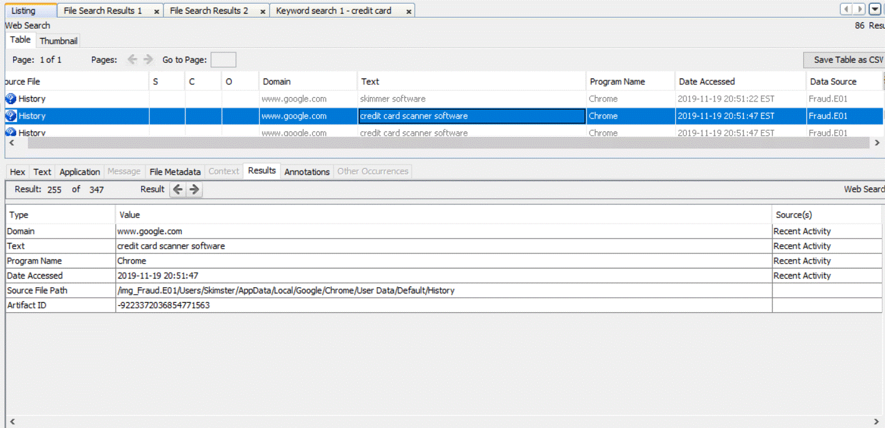

Screenshot provides solid evidence that Frauder looked up dark web skimmers as well so he could sell the stolen credit-card information to shady people on the dark web or black market

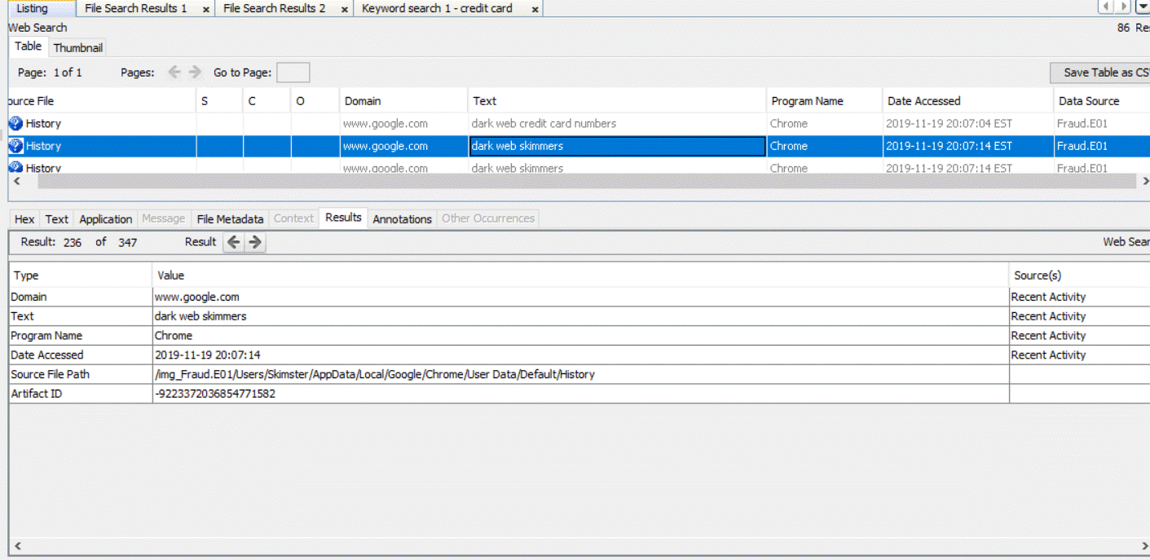

Screenshot depicts hard evidence that Frauder researched dark web credit-card numbers so he could steal credit-card numbers from the dark web as well

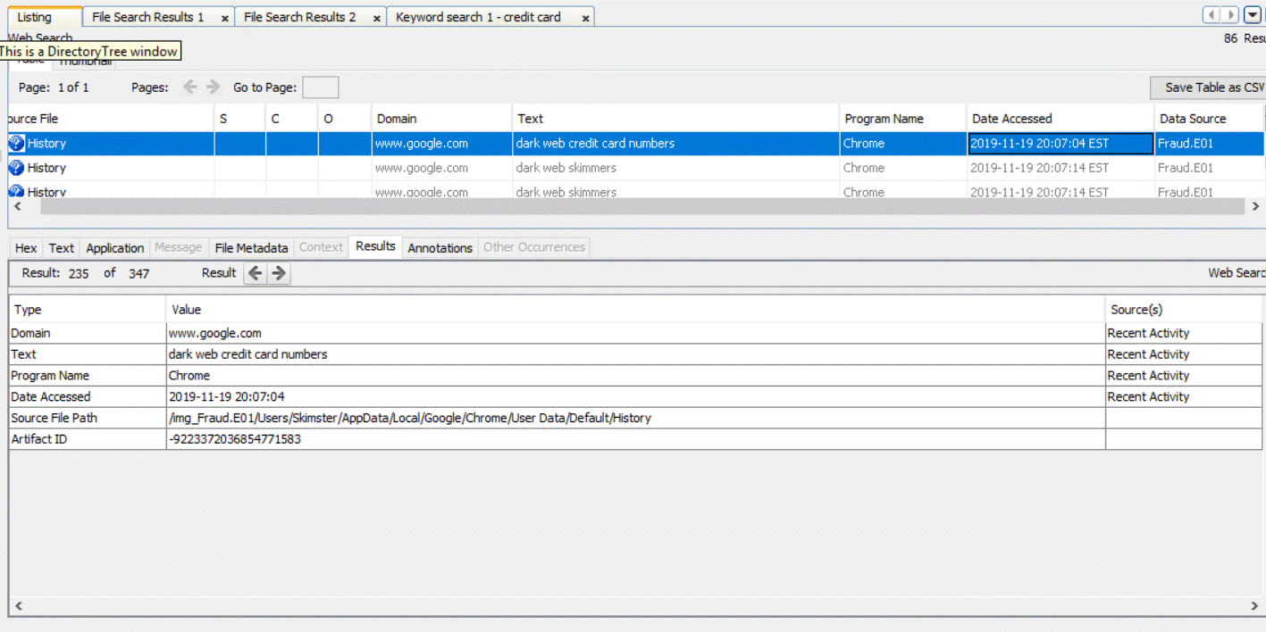

Screenshot provides strong evidence that Frauder looked up a software known as MISIRI most likely so he could use it as a repository to store his stolen credit-card information

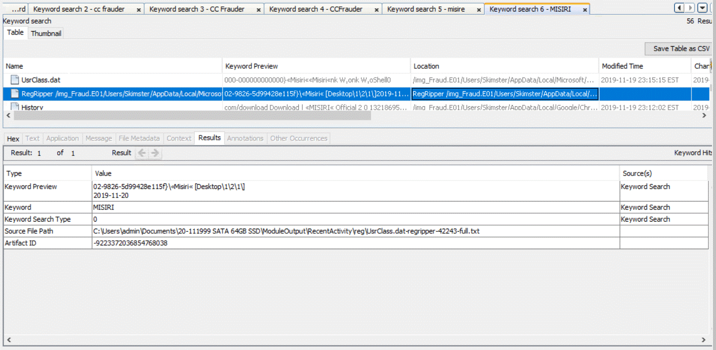 Screenshot provides solid evidence that Frauder researched gas pump skimmers so he could steal customers credit-card information when they used their credit-card at the gas pump to pay for their gas

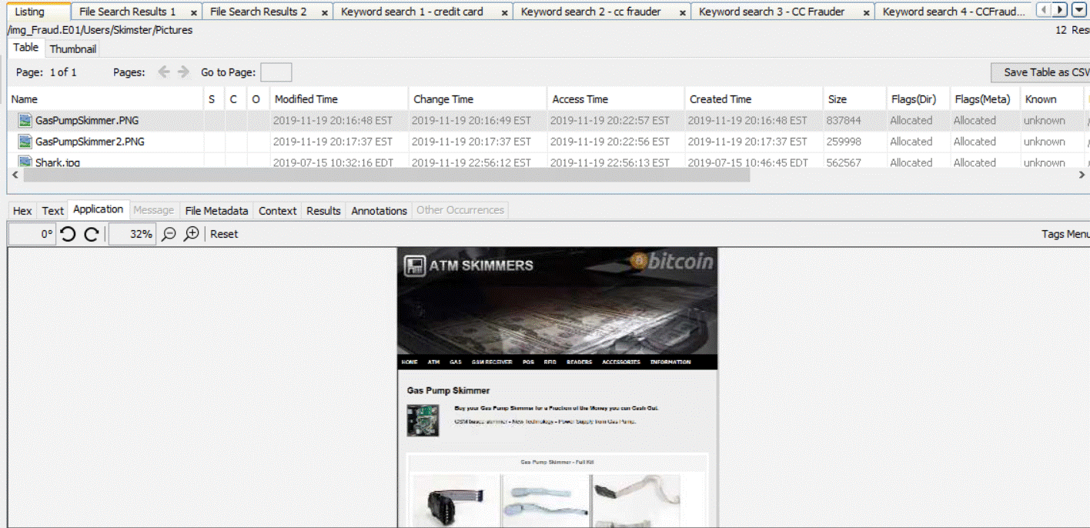

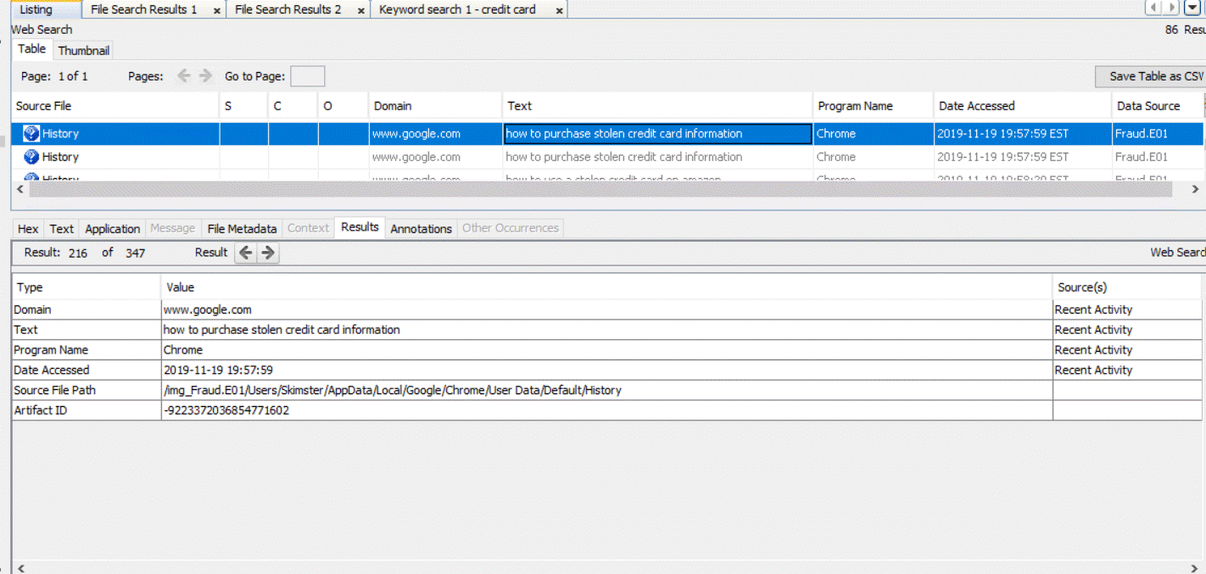Screenshot provides solid evidence that Frauder researched how to purchase stolen credit-card information so he could buy merchandise with it

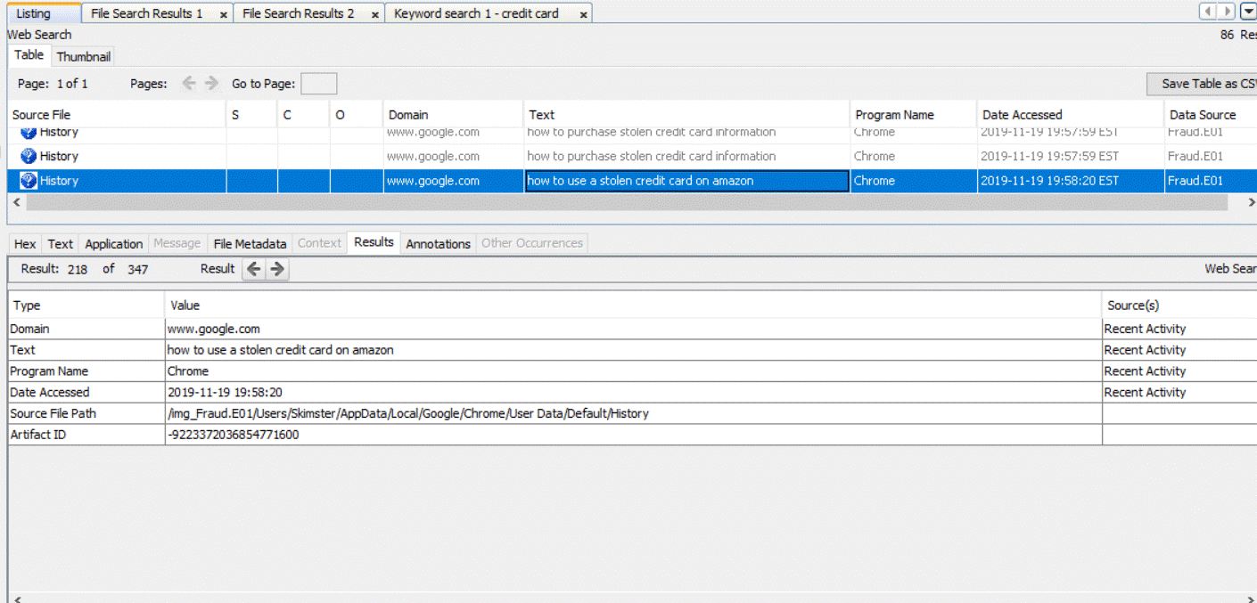Screenshot proves that Frauder researched how to use a stolen credit-card on amazon if he didn’t look this up, he wouldn’t be able to buy anything with the credit-cards he stole

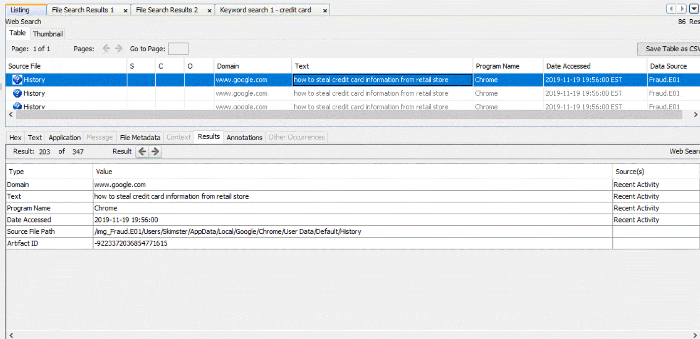Screenshot depicts strong proof that Frauder looked up how to steal credit card information from a retail store he researched this so he could acquire more illicit funds to purchase more things

Screenshot provides solid evidence that Frauder logged into his email account to initiate a conversation with his associate

Screenshot provides strong evidence that Frauder downloaded the software he wants to use to store all the credit-card information he stole

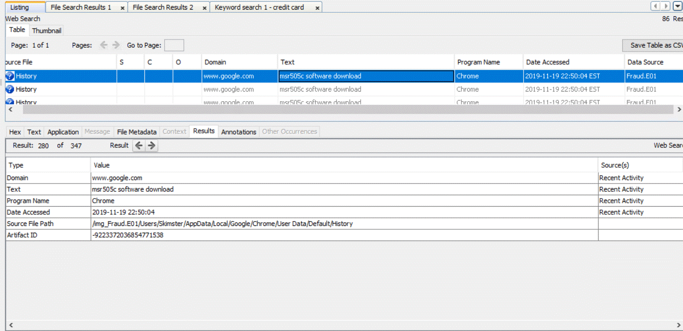

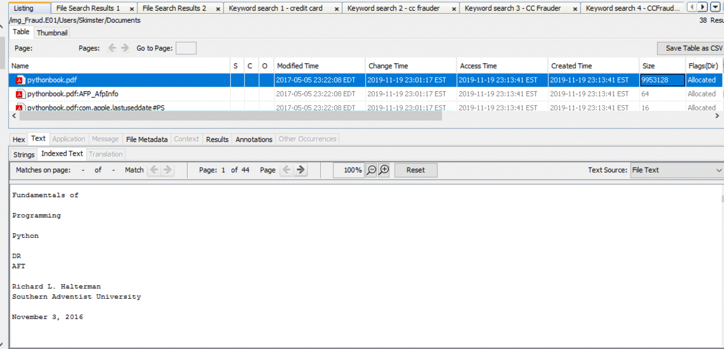This image provides proof that Frauder researched how to write code in python most likely so he could write a program to translate the stolen credit-card information into a cryptocurrency like Bitcoin

This image provides proof that Frauder deleted the Skimster software from his laptop before the detective seized it via the search warrant to cover his tracks

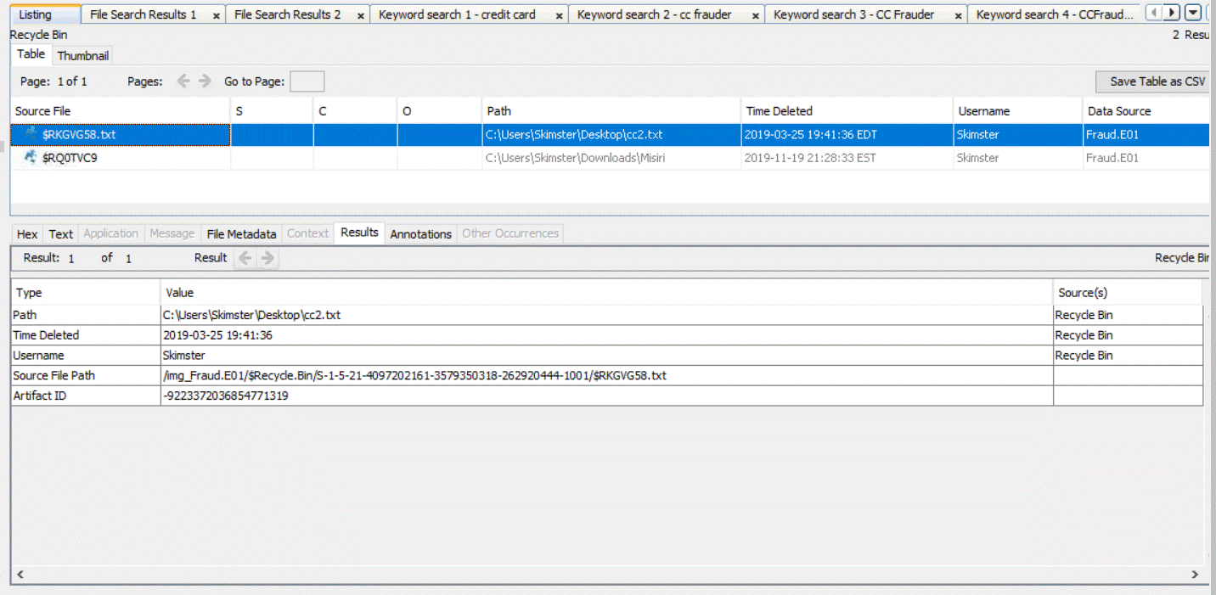

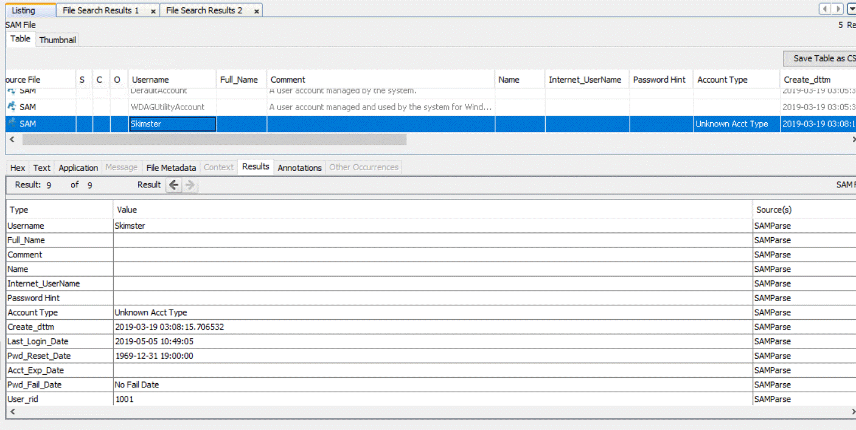Screenshot provides solid proof that Frauder logged into his Skimster software most likely to input and store the credit-card information that he stole from people

Screenshot shows the StandardName and StandardBias of the TimeZone of Frauder’s laptop

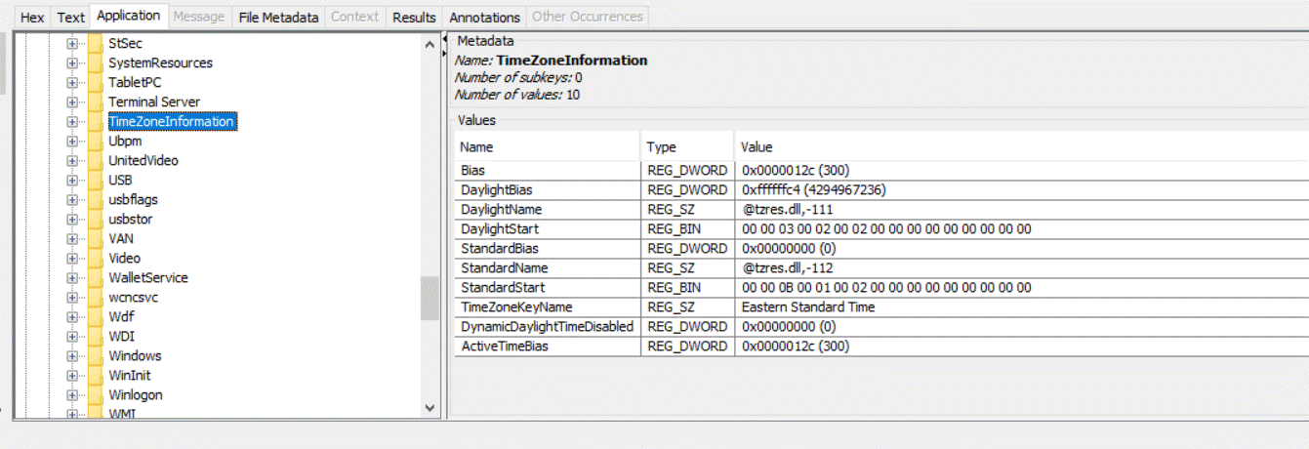

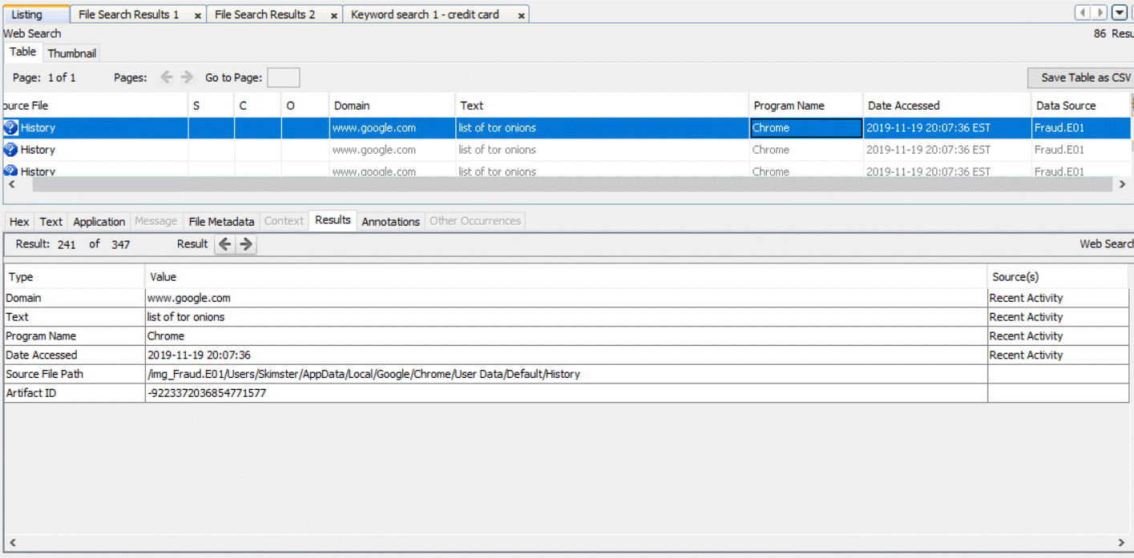Screenshot provides proof that Frauder researched a list of tor onions, so he’d have the capacity to communicate anonymously with his associate

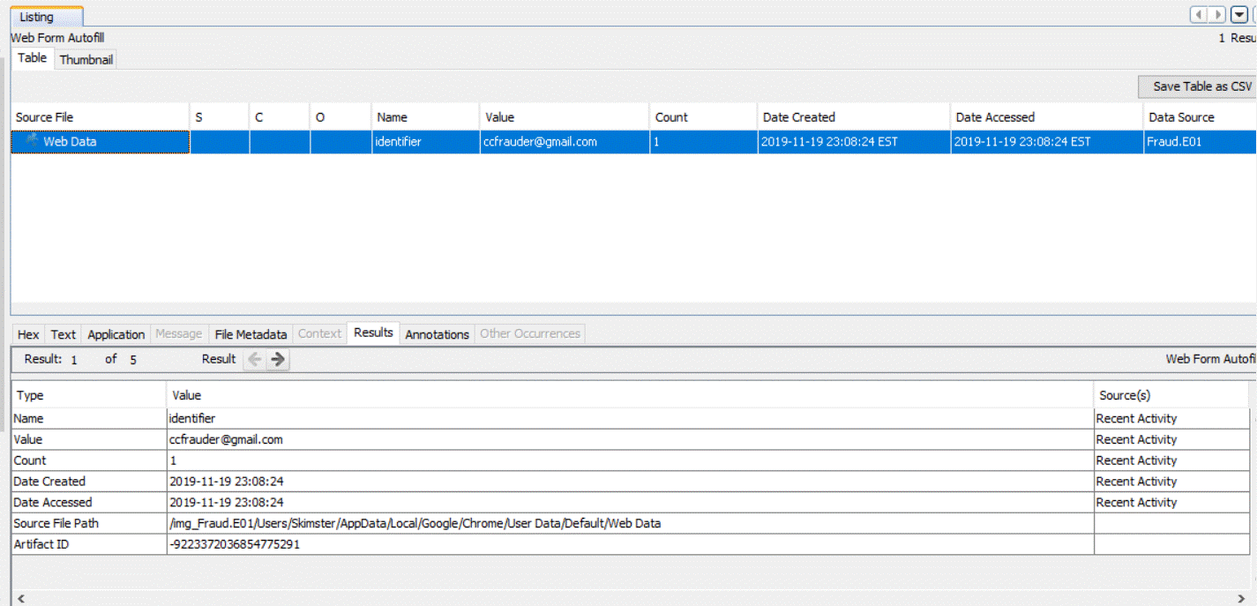 Screenshot shows when Frauder created and access his email account

Attachments/Appendices

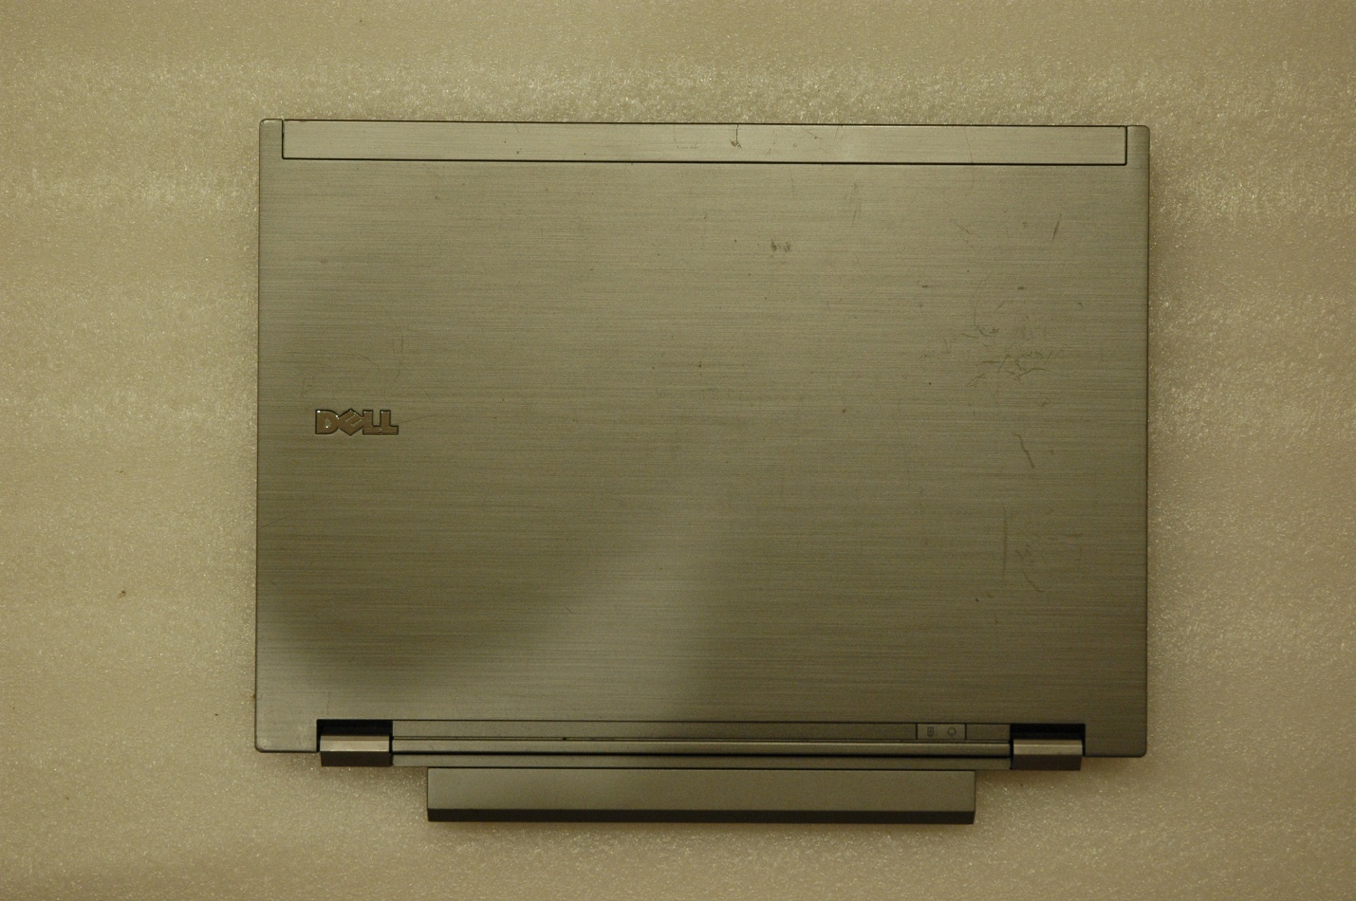Picture Caption: Frauder’s Laptop facing upward on a table

Picture Caption: Frauder’s laptop facing backwards on a table

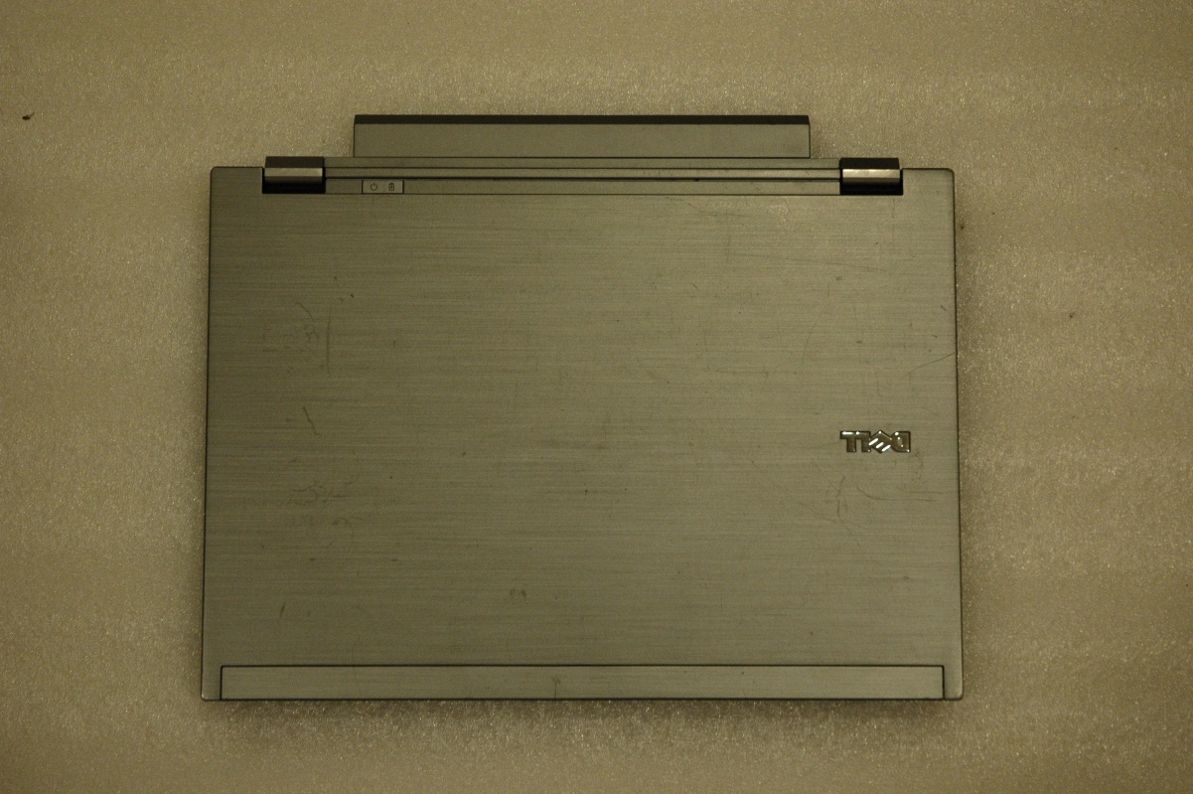

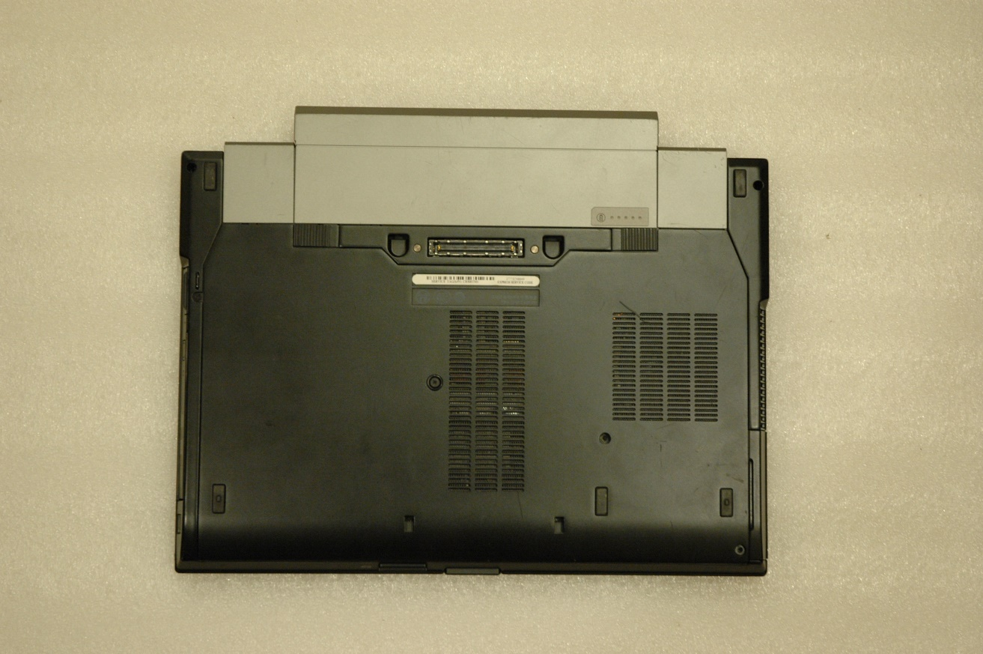Picture Caption: The bottom of Frauder’s laptop facing up on a table

Picture Caption: The bottom of Frauder’s laptop facing up on a table

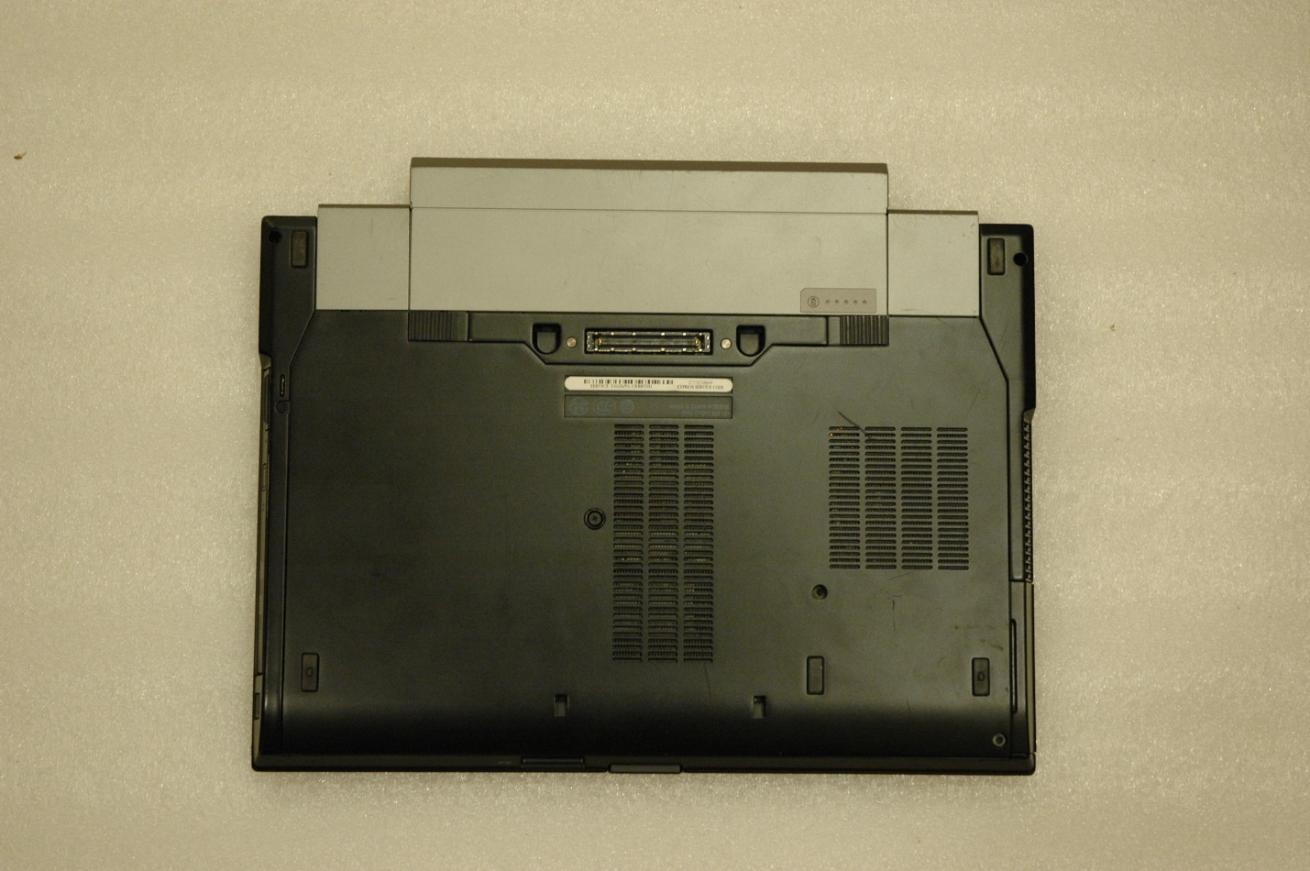

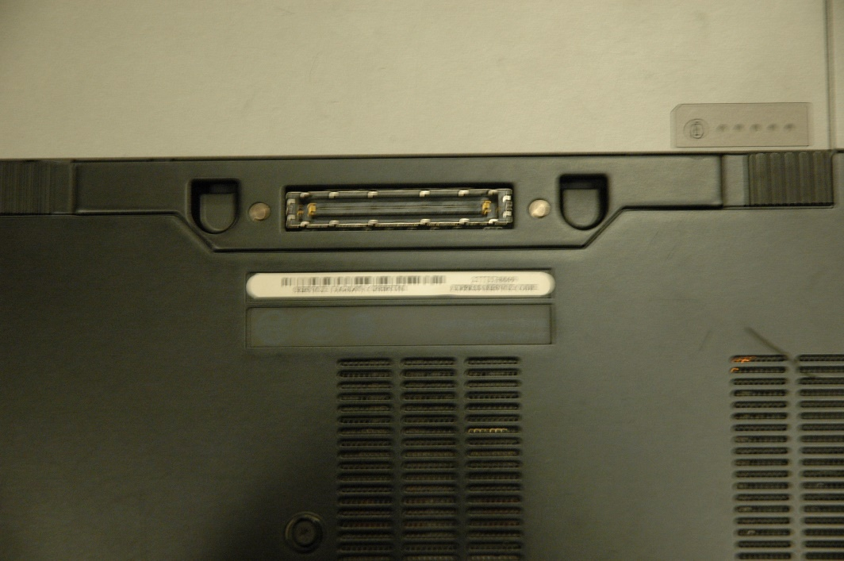Picture caption: Frauder’s laptop is fully opened and is lying facedown on a table

Picture caption: Frauder’s laptop is fully opened and is lying face down on a table

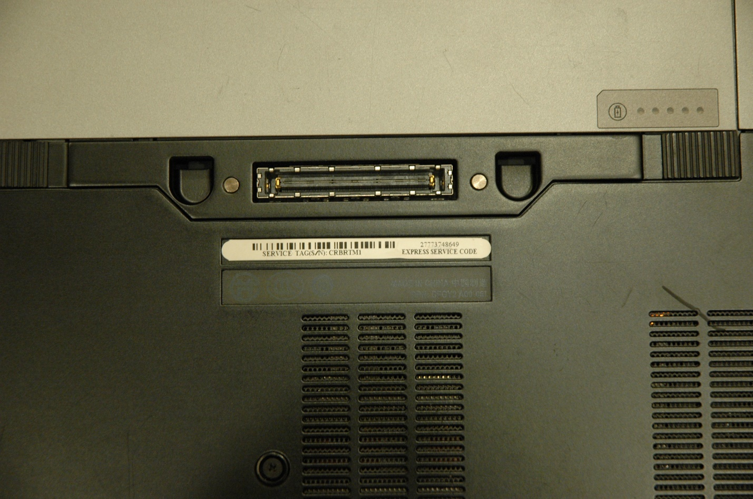Picture Caption Frauder’s laptop is placed faceup on a table with the schematics of the laptop showing

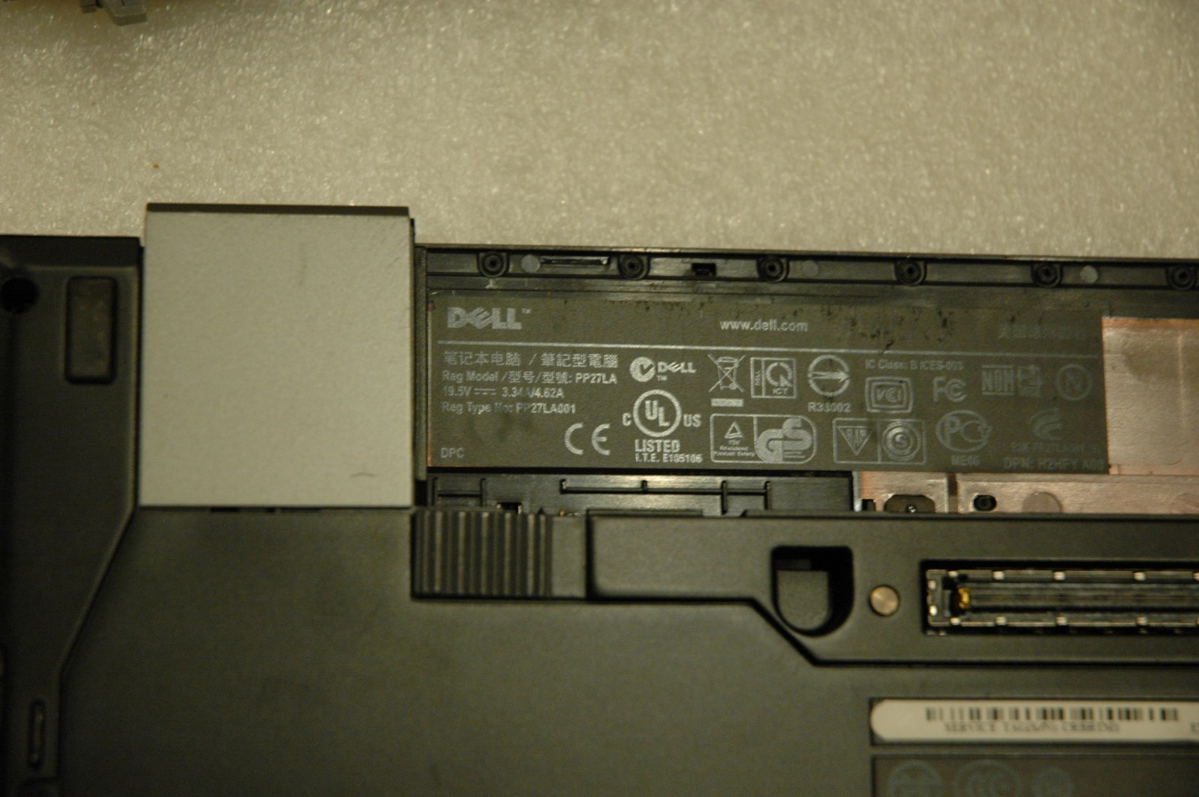

Picture Caption: Frauder’s laptop is opened with part of the keyboard showing and its facing sideways

Picture Caption: The screen and keyboard of Frauder’s laptop have been taken apart

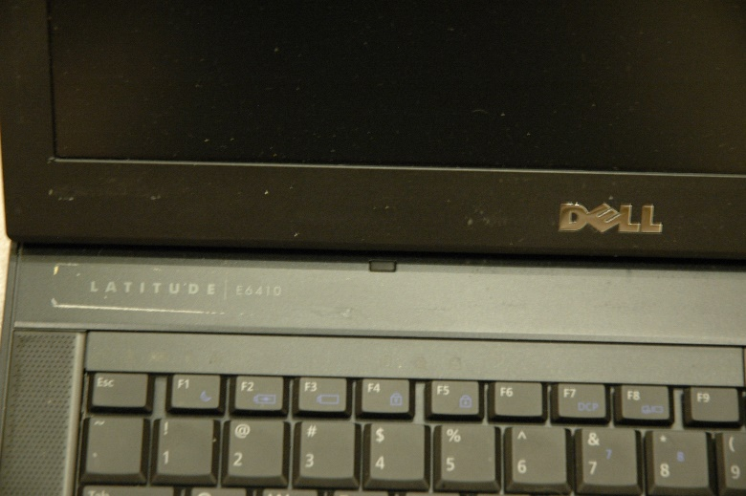

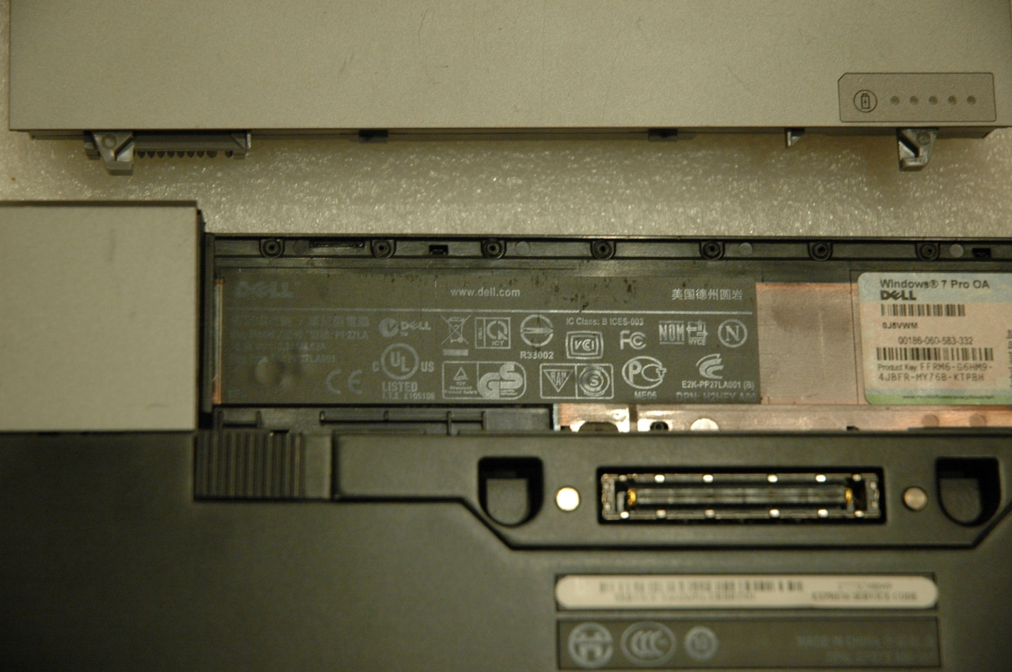

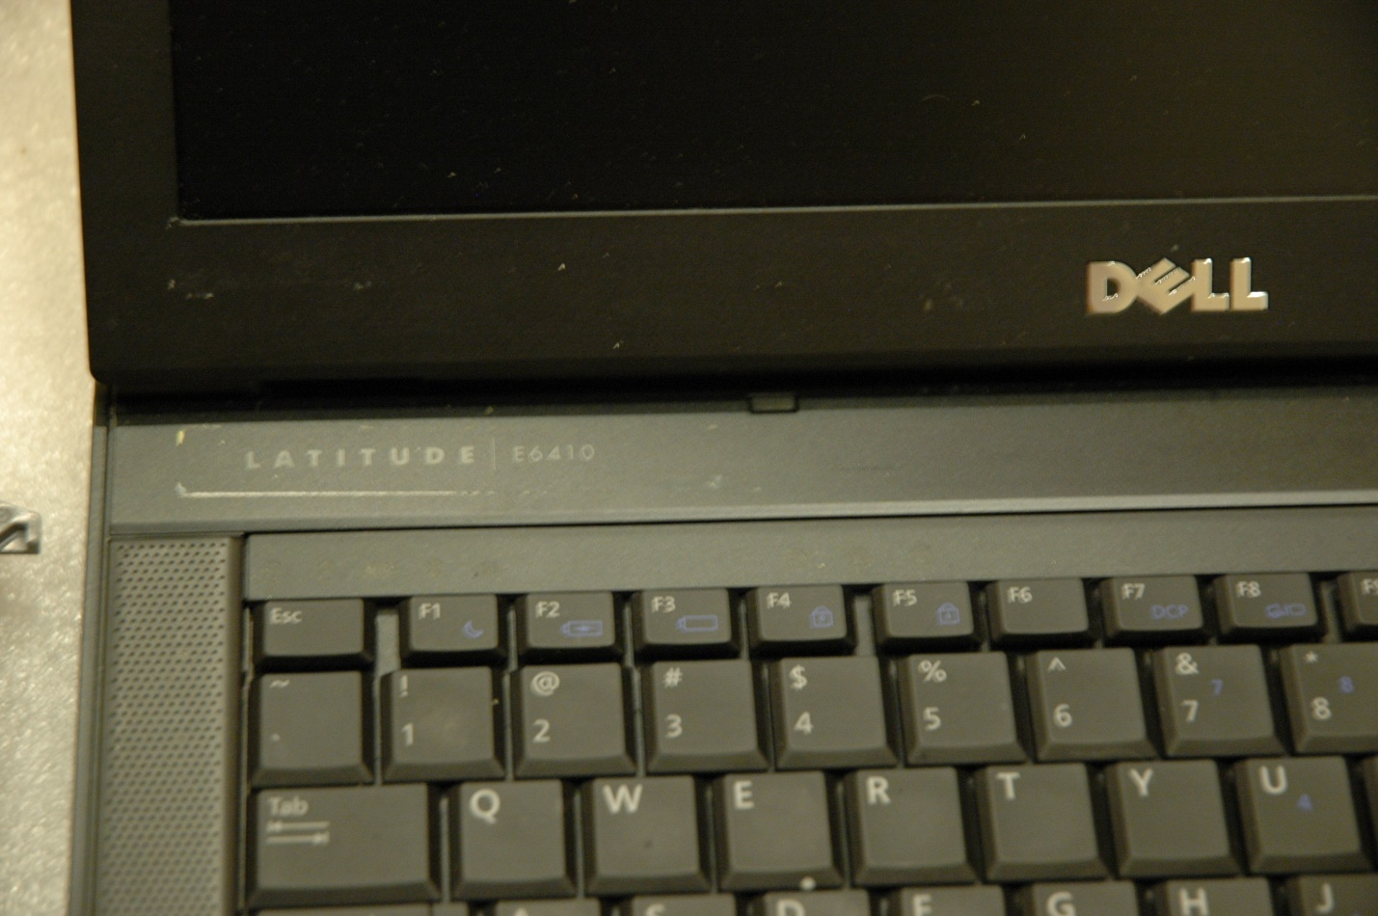Picture Caption: Frauder’s laptop is opened with part of the keyboard showing and its facing upright

Picture Caption: The hardrive of Frauder’s laptop is shown enclosed in a protective case

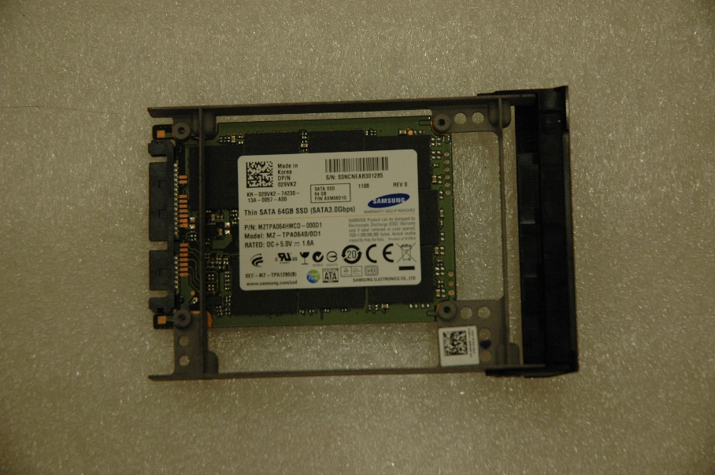

Picture Caption: The hardrive of Frauder’s laptop is shown enclosed in a protective case

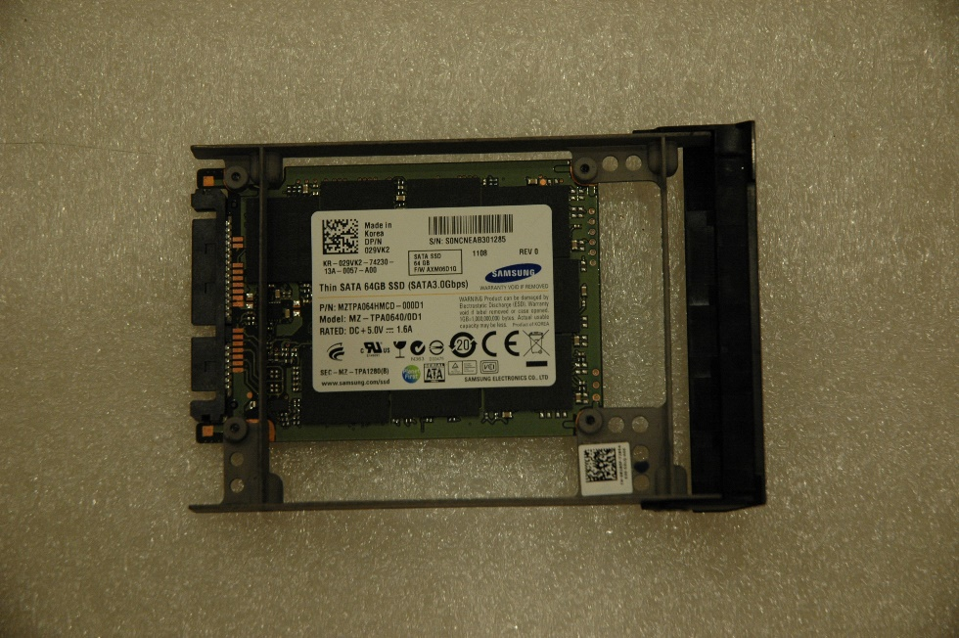

Picture Caption: The motherboard of Frauder’s laptop is shown and enclosed in a protective case

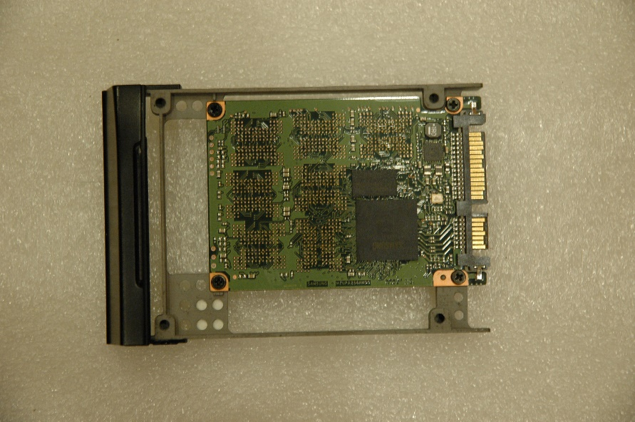

Picture Caption: The motherboard of Frauder’s laptop is shown and enclosed in a protective case

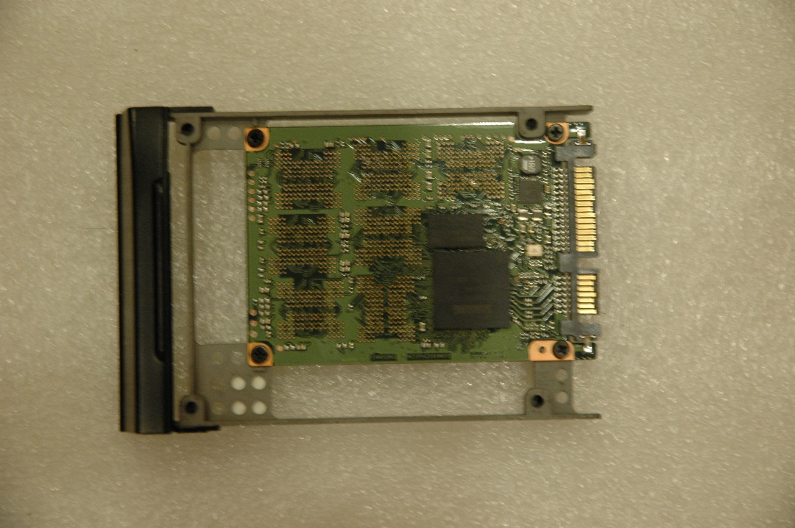

Were any USB devices attached?  If so, what continued from page 9

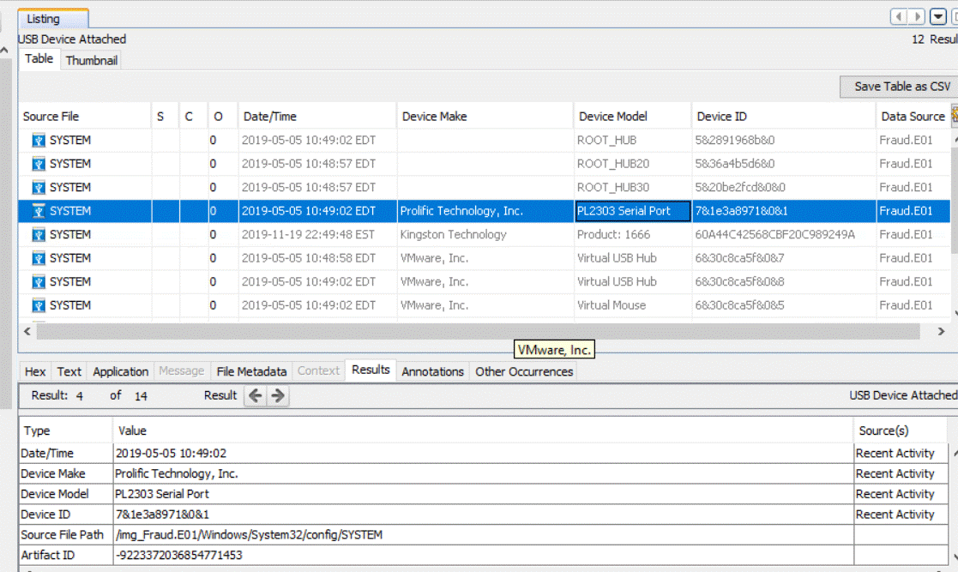Screenshot Caption: Frauder had a PL2303 Serial Port attached to his laptop

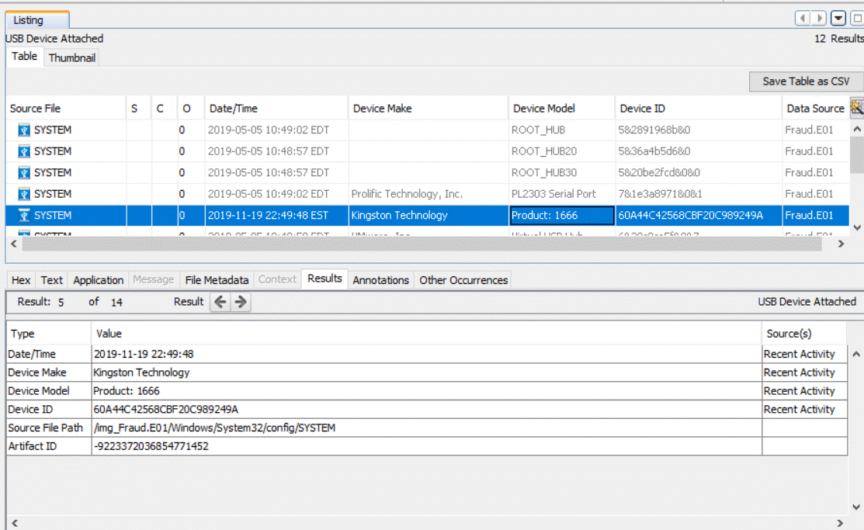Screenshot Caption: There was a USB device with model number 1666 manufactured by Kingston Technology Inc. attached to Frauder’s laptop

Screenshot Caption: A Virtual USB Hub manufactured by VMware Inc. was attached to Frauder’s laptop

Conclusion

My opinion of this case is based on facts, and I certainly can substantiate it with my findings Chris Frauder wanted to pull off the biggest credit-card skimming scam in history. He conducted extensive research before he started his scam. He researched everything from what skimmers and credit-card scanners to purchase. How to steal, buy, and use stolen credit-card information, how to validate stolen credit-card information, etc., because he wanted to ensure that his scam would go according to plan so he wouldn’t get caught by the local police or the feds.